Setting Time Zone in Oracle
1.After logging into the portal click on your initials in the top right-hand corner.
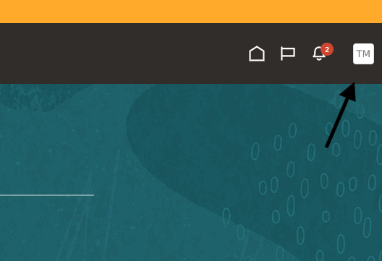

2. Click “Set Preferences” from menu options.
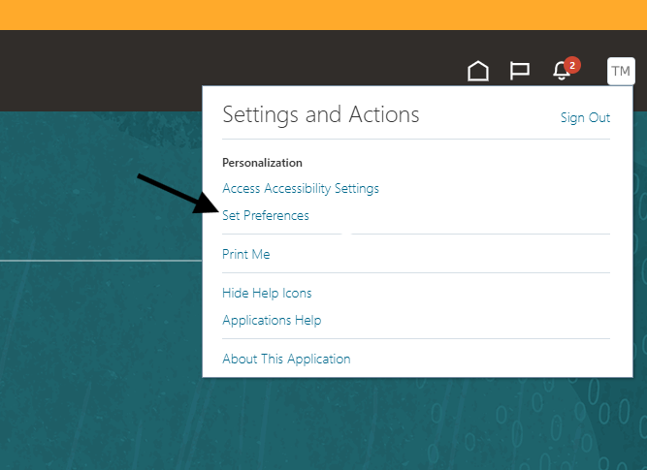

3. Click “Regional” under General Preferences.
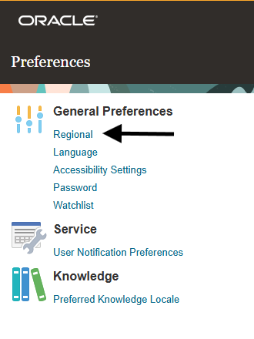

4. Find the time zone field. Scroll through the list and select your time zone. Do not keep "Coordinated Universal Time" as the time zone.
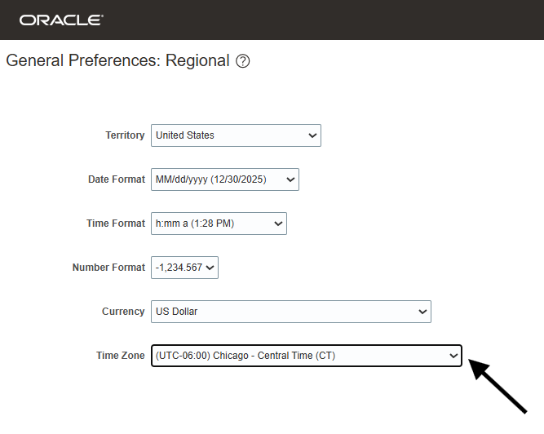

5. Click “Save and Close” in the upper right-hand corner.
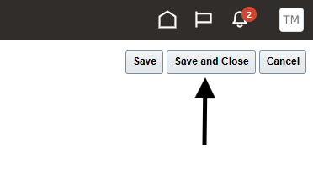

6. Click the Home icon to return to the home screen.
