Basic Navigation
After logging in you will find the following icons in the upper right-hand corner of the screen.
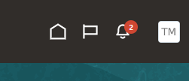

The house icon will return you to the home screen. At any time you can click this icon to return to the home screen.
The flag icon will provide a watchlist of items that may need your attention.
The bell icon is a list of notifications. The system will also email notifications to you.
The initials icon provides the “Settings and Actions” menu. This is where you will set your time zone.

Reminder: Always use the icons and buttons in Oracle to navigate between screens. Do not use the back button in your internet browser.

Most of your work will be completed in the Supplier Portal Application.
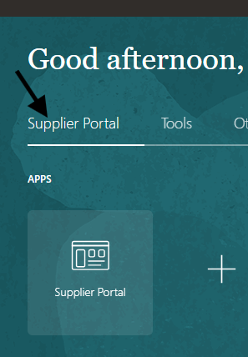
Use the large Supplier Portal app button to open the Supplier Portal.
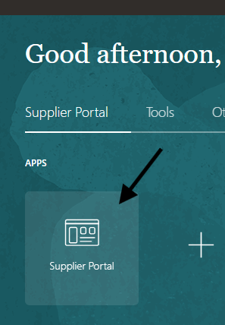

On the supplier portal page, you can view notifications, supplier news, additional links and click into several other areas to view orders, invoices, payments, agreements, and much more.
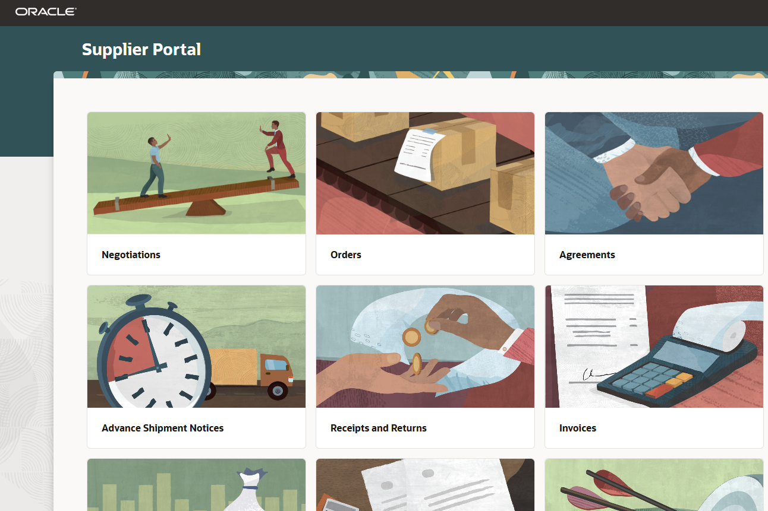
When you are finished working in Oracle, click on your initials, then click sign out.
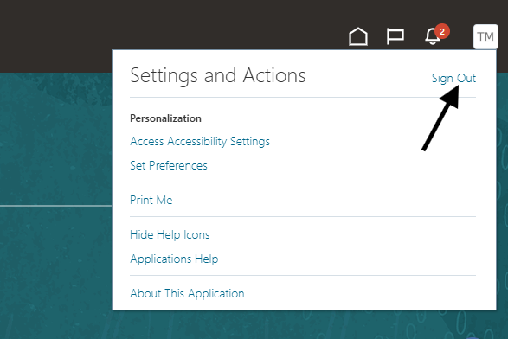

Click the "Confirm" to finish signing out.
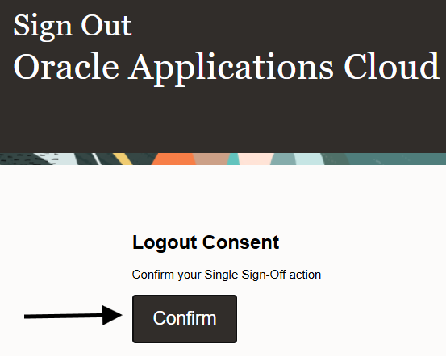

Oracle Guided Learning
Learn how to use Oracle Guided Learning (OGL) in Talon to access real-time, step-by-step instructions that guide you through completing key processes within the system.
You can find the Oracle Guided learning widget inside the portal. If you put your cursor on the bottom portion where the dots appear you can move the widget around the screen. If you use your mouse to click the “I” it will open the widget to allow you to search for guides to help step you through specific processes in the portal.


